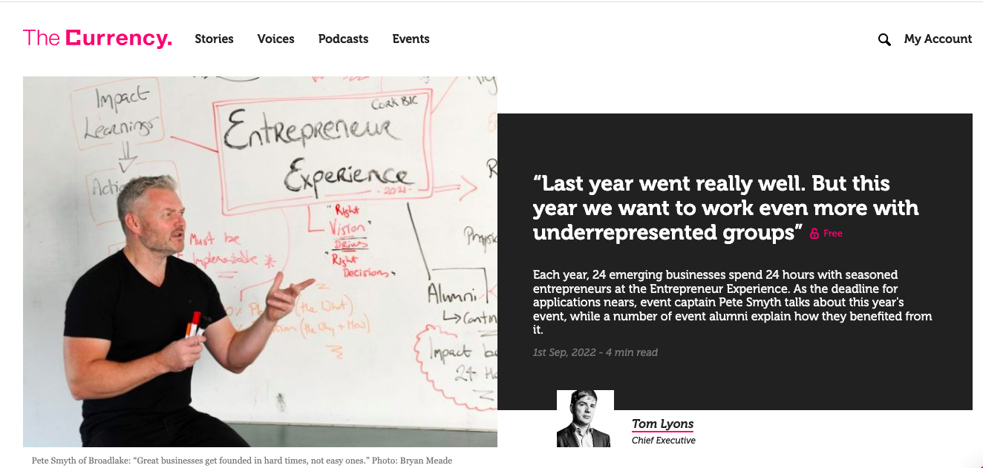

“Last year went really well. But this year we want to work even more with underrepresented groups”

Pete Smyth chats to Tom Lyons from the Currency about the 2022 Entrepreneur Experience who should apply and Why?

Link to the article:

https://thecurrency.news/articles/94792/last-year-went-really-well-but-this-year-we-went-to-work-even-more-with-underrepresented-groups/

